

Structural Design

(Inside View)

**Vertical corrugation**

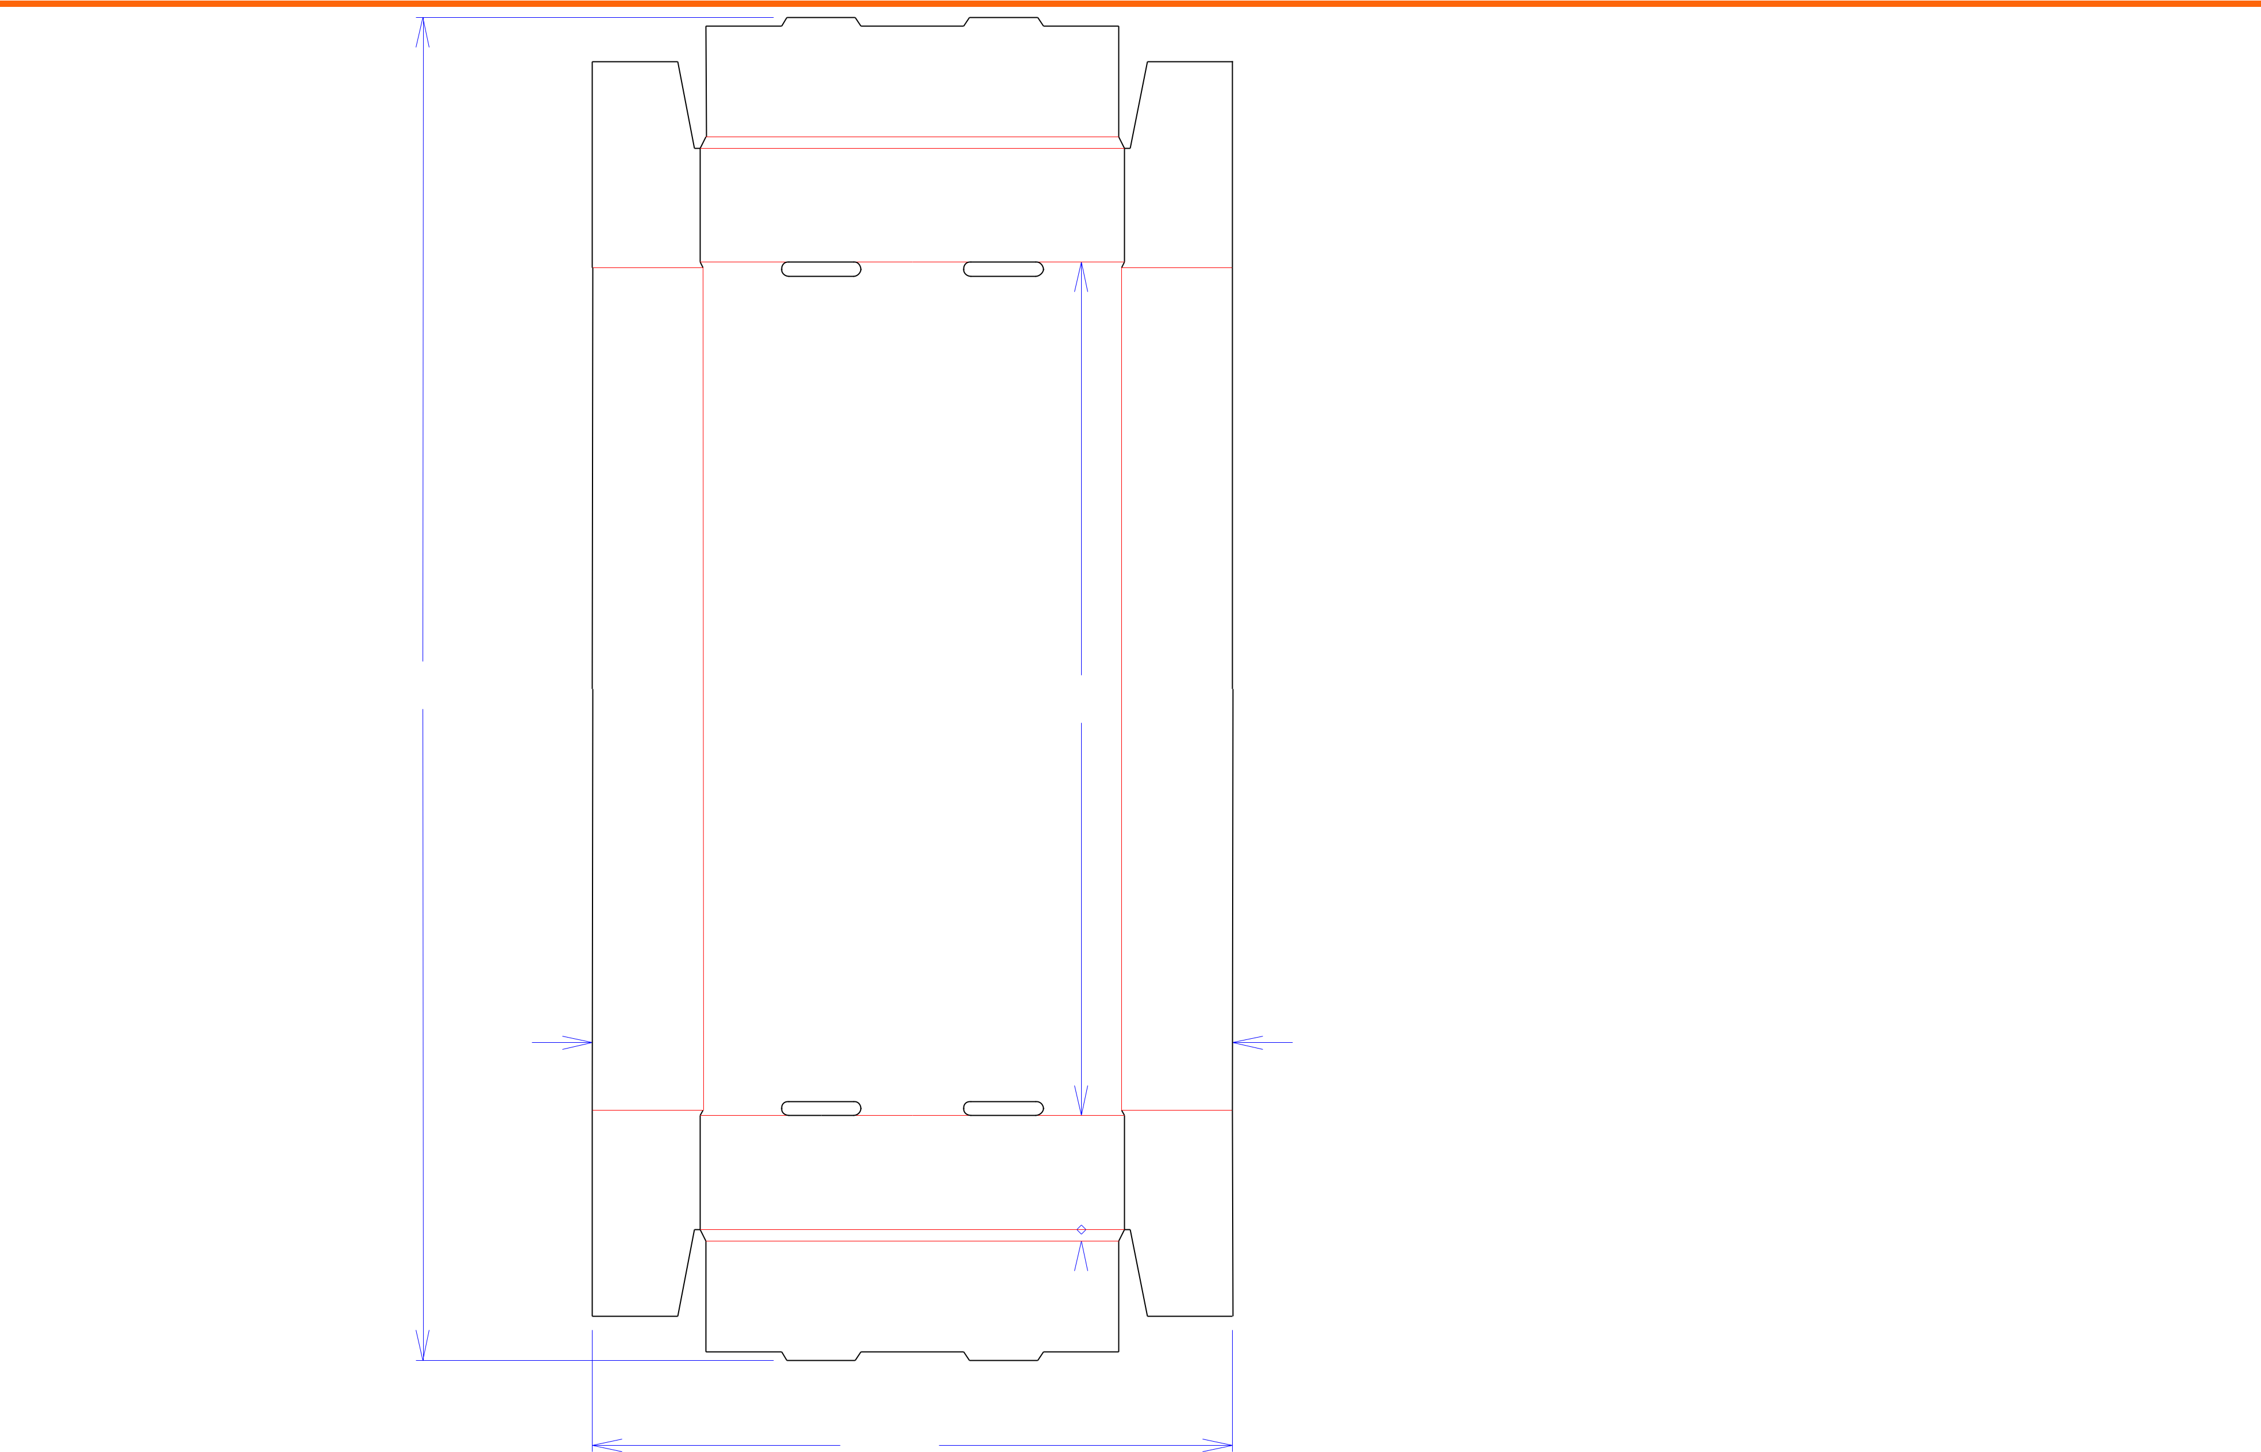

Design#:

**90563-01**

Customer:

**DeMet's Candy**

Description:

**TRY-.801/0**

|  |  |  |  |  |  |
| --- | --- | --- | --- | --- | --- |
|  |  |  |  | **SINGLE-OUT DRAWING** |  |
|  |  |  | Qty/Unit: | |  |
|  |  |  | Style: | **NJDC** |  |
|  |  |  | Board: | **32BW** |  |
| 291*/*2 | 3 | | Combination: **36MW - 23M - 35HP** | |  |
|  |  |  |
|  | 18 | */*4 | I.D. : | **18+1/8 x 9+1/16 x 2+1/2** |  |
|  |  |  |  |

Area of Blank - Waste : **2.76 sq. ft.**

Waste on Blank : **4.16%**

Finished Piece Weight: **0.29 lbs./131.09g**

Over-all Blank: **29+1/2 x 14+1/16**

27*/*16  93*/*16  27*/*16

|  |  |  |  |
| --- | --- | --- | --- |
| 21*/*2 | | Notes: |  |
| **Copied from customer sample** |  |
|  |  |  |  |
|  |  |  |  |
|  |  |  |  |

|  |  |  |  |
| --- | --- | --- | --- |
| 1*/*4 | Revision Info: | **[0] 06/10/2009** |  |
|  |  |

|  |  |  |  |  |  |  |  |  |  |  |  |  |  |  |  |
| --- | --- | --- | --- | --- | --- | --- | --- | --- | --- | --- | --- | --- | --- | --- | --- |
|  |  |  | 141*/*16 |  |  |  |  |  |  |  |  |  |  |  |  |
|  |  |  |  |  |  |  |  |  |  |  |  | Designer: | **LEGACY** |  |
| Cut | Crease | Crease with Matrix | Cut Crease | Half Knife Cut | Tear Tape | | | | | | | Perforation | |  |  |
|  |  |  |  |  |  |  |  |  |  |  |  |  |  |  |  |



Designright and Copyright of DS Smith Corrugated Packaging Ltd. This technical Specification is subject to Manufacturing tolerances. Drawing dimensions shown are crease to crease. Date printed: 11/05/2018